Lab Assignment Number: 19.5

Name: CH.Nanda kishore
HT No:2303A51638
Batch No:23

Task 1 – Python List Processing → C++ STL Conversion
Task:
Translate a Python program that filters even numbers from a list into
C++.
Instructions:
- Provide AI with Python list comprehension code.
- Convert it into C++ using vectors and loops/STL.
- Verify outputs for the same input list.
Expected Output:
- Equivalent working C++ program using STL.
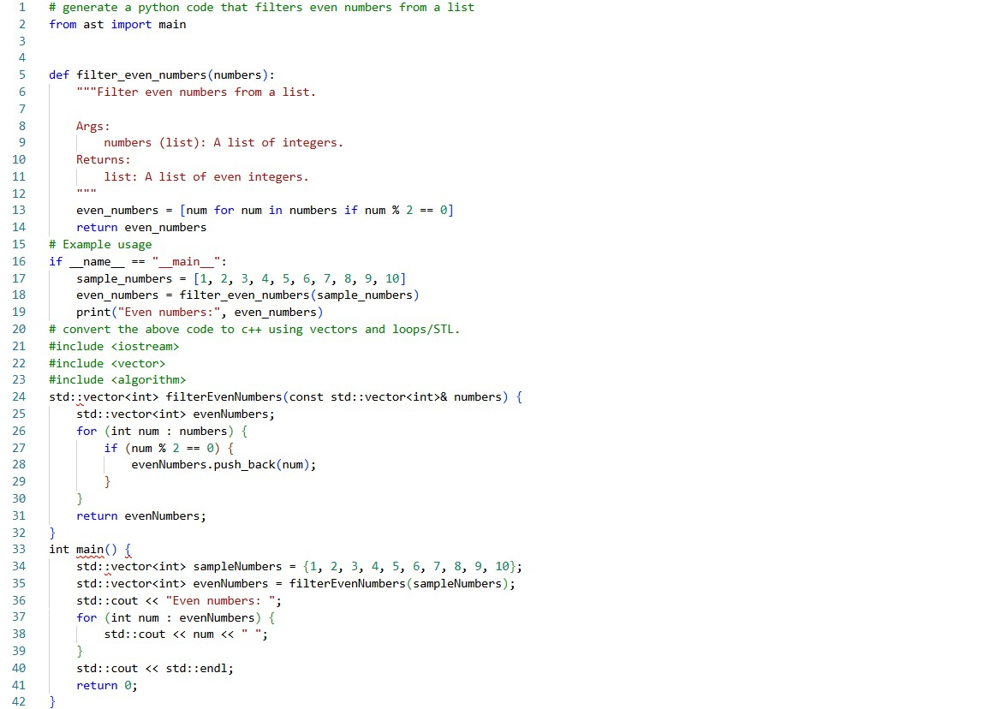

Task 2 – Java to Python OOP Translation
Task:
Convert a Java Student class into an equivalent Python class.
Instructions:
- Translate attributes, constructor, and methods properly.
- Ensure Python version uses __init__ and follows Python conventions.
- Test both versions with sample objects.
Expected Output:
- Correct Python OOP class translated from Java
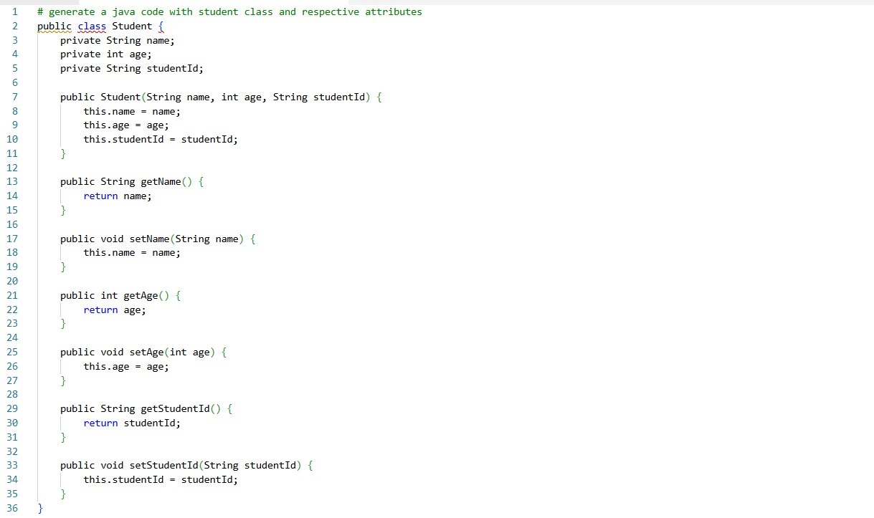
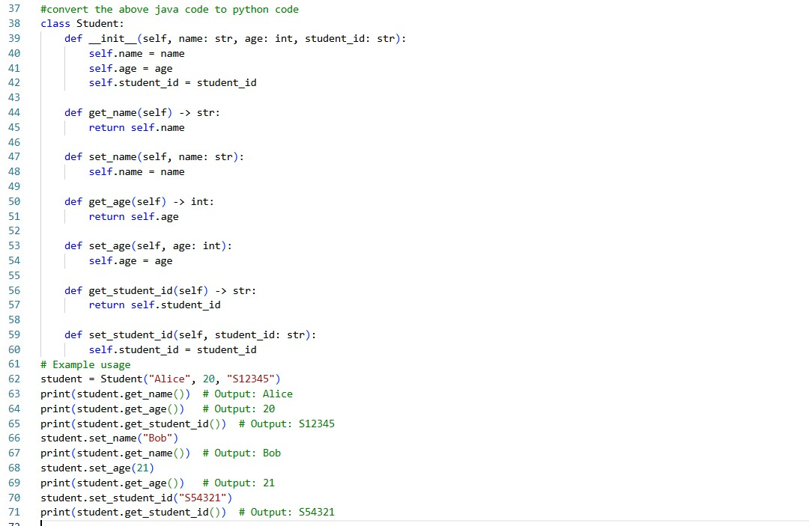

Task 3 – SQL Aggregation Query → Pandas GroupBy
Task:
Convert an SQL query with aggregation into Pandas.
Example SQL:
SELECT department, AVG(salary)
FROM employees GROUP BY department;
Instructions:
- Translate into Pandas groupby() and mean().
- Validate using sample DataFrame.
Expected Output:
- Equivalent Pandas aggregation code.
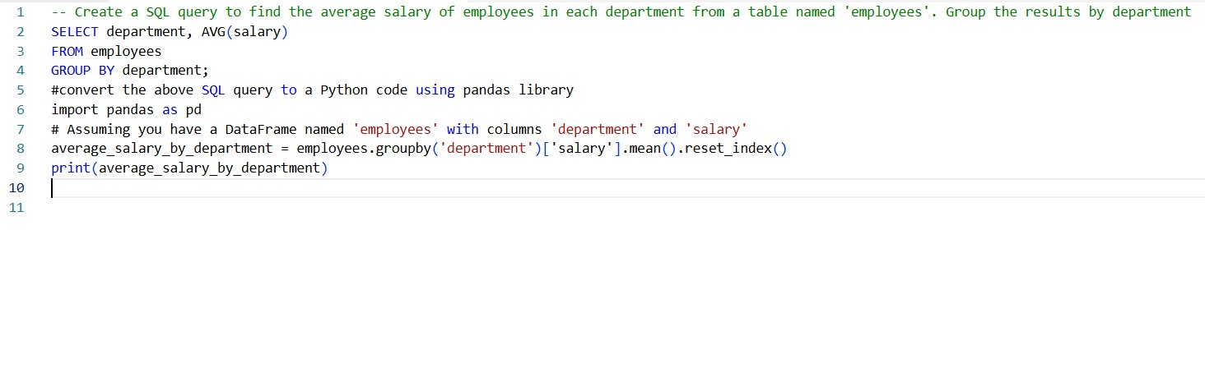

Task 4 – Python File Handling → C++ File Streams
Task:
Convert a Python program that reads a text file and counts words into C++.
Instructions:
- Translate open() usage into ifstream.
- Handle file-not-found errors properly.
- Compare outputs for the same file.
Expected Output:
- Working C++ word counter program.
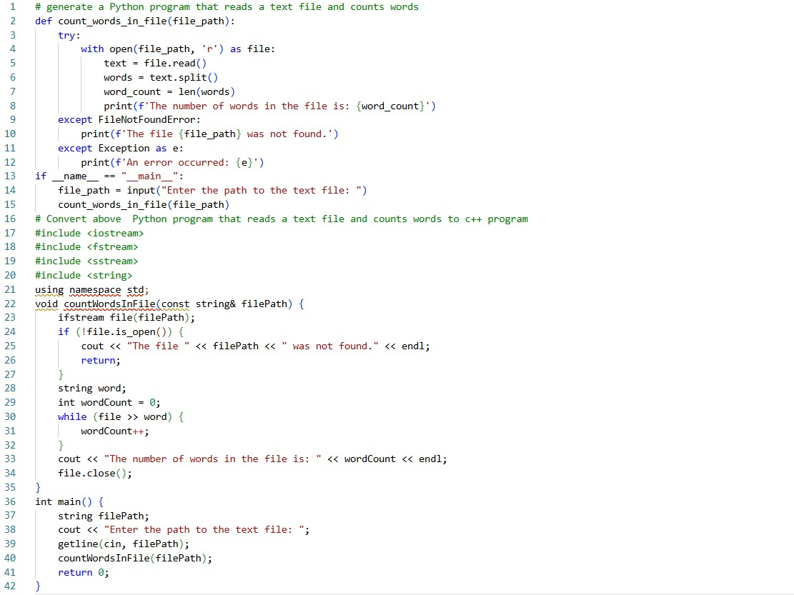

Task 5 – Java Exception Handling → Python Try/Except
Task:
Translate a Java program using try-catch for division into Python.
Instructions:
- Convert exception syntax properly.
- Handle divide-by-zero gracefully.
- Verify both programs behave the same.
Expected Output:
- Equivalent Python error-handling program.
